**Most Popular Browsers on OS**

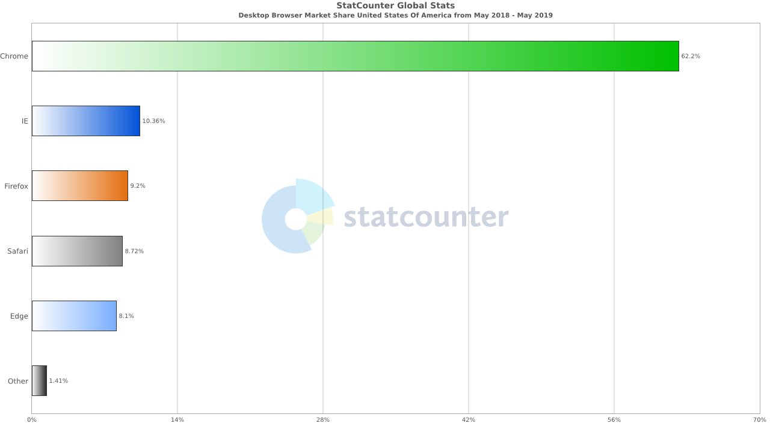

**Most Popular Browsers on Mobile**

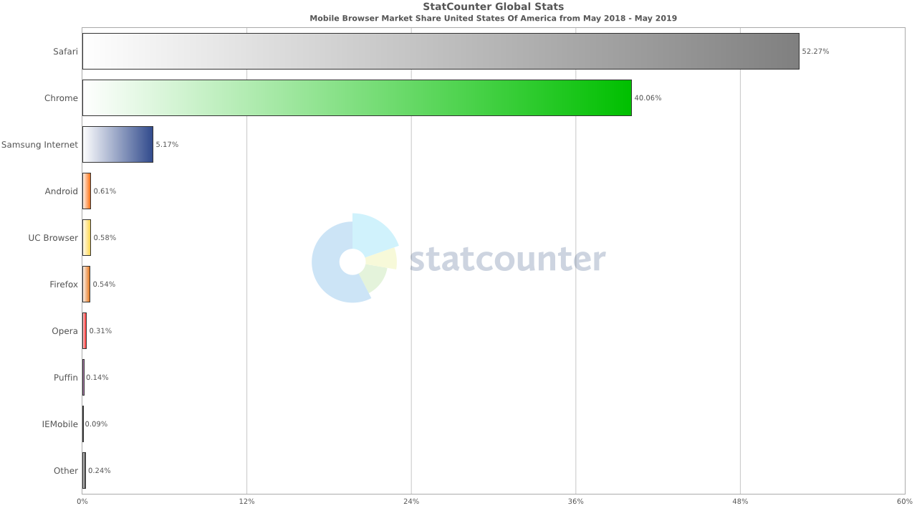

**Most Popular Browsers on Tablet**

